**ASSIGNMENT III SOLUTION**

**NAME: Debasis Mohanty**

**ROLL NO. : UEBA19001**

Q1. Solve the following by KKT conditions

Ans1:

Given $Max Z= f\left(x_{1},x_{2}\right)= 3.6x_{1}-0.4x_{1}^{2}+1.6x_{2}-0.2x_{2}^{2}$

Subject to $h\left(x,x_{2}\right)= 2x_{1}+ x_{2}≤10$

$x_{1} , x_{2}≥0$

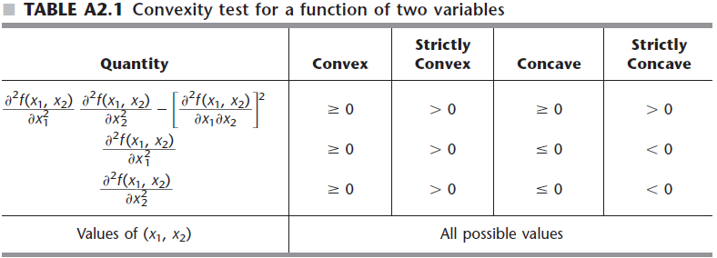

We could see that $f\left(x\right)$ is a concave function and $h\left(x\right)$ is a convex function. Hence, the corollary applies, so any solution that satisfies the KKT conditions will definitely be an optimal solution. Changing it to a minimization problem $(- f\left(x\right))$ and solving it by applying the formulas given in the KKT theorem discussed in the class we have:

$$Min Z= -3.6x_{1}+0.4x_{1}^{2}-1.6x_{2}+0.2x_{2}^{2}$$

Subject to $h\left(x\right)= 2x_{1}+ x_{2}≤10$

$x_{1} , x_{2}≥0$

Stationarity (first order conditions) : $0 ϵ δf\left(x\right)+ \sum_{i=1}^{m}{μ_{i}}dh_{i}(x)$

$$\frac{δ}{δx_{1}}\left(-3.6x_{1}+0.4x_{1}^{2}-1.6x_{2}+0.2x_{2}^{2}\right)+ \frac{δ}{δx_{1}} \left(\left(2x_{1}+ x_{2}-10\right)μ_{1}\right)$$

$$-3.6+0.8x_{1}+ 2μ_{1}=0 ----Eqn(1)$$

$$\frac{δ}{δx_{2}}\left(-3.6x_{1}+0.4x_{1}^{2}-1.6x_{2}+0.2x_{2}^{2}\right)+ \frac{δ}{δx_{2}} \left(\left(2x_{1}+ x_{2}-10\right)μ_{1}\right)$$

$$-1.6+0.4x_{2}+μ_{1}=0 ----Eqn(2)$$

Complementary Slackness: $μ_{i}h_{i}\left(x\right)=0, for all i$

$$\left(2x_{1}+ x_{2}-10\right)μ_{1}=0$$

Primal feasibility: $h_{i}\left(x\right)≤0, for all i$

$$2x_{1}+ x_{2}-10≤0$$

Dual feasibility: $μ_{i}≥0, for all i$

$$μ_{1}≥0$$

Case 1: $μ_{1}=0$

Putting the value in the Eqn(1) and Eqn(2) we have:

$$x_{1}= \frac{3.6}{0.8}=4.5 , x_{2}= \frac{1.6}{0.4}=4$$

Putting the above values in primal function we have:

$$2x_{1}+ x_{2}-10≤0$$

$2*4.5+ 4-10=3$ which is not $≤0$

This doesn’t satisfy the primal feasibility so, moving on to further case.

Case2: $2x_{1}+ x_{2}-10=0$

$$x_{2}=10- 2x_{1} ----Eqn(3)$$

Putting the above value in the Eqn(2) we have:

$$-1.6+0.4(10- 2x_{1})+μ_{1}=0$$

$$-1.6+4- 0.8x_{1}+μ_{1}=0$$

$$- 0.8x_{1}+μ_{1}=-2.4 ----Eqn(4)$$

$$0.8x_{1}+ 2μ_{1}=3.6 ----Eqn(5)$$

Solving the above two equations we get

$$μ_{1}=\frac{1.2}{3}=0.4$$

Putting the value back in Equ(1) we have

$$-3.6+0.8x_{1}+ 0.8=0$$

$$x_{1}= \frac{2.8}{0.8}=3.5$$

Putting the value of $x_{1}$ in Equ(3) we have:

$$x_{2}=10- 7=3$$

The above values of $x_{1} and x_{2}$ satisfies the primal feasibility.

Hence, for $μ_{1}=0.4$ the above solution ${x_{1 }=3.5 and x}_{2}=3$ obeys all the 4 KKT conditions. So, we got the local optima which is the local maximum value for the given function.

Q2. What is a pure birth and death process? Give two examples of heuristics except Genetic algorithm.

Ans 2:

A pure birth process is a birth–death process where $μ_{i}=0$ for all $i≥0$. No decrements only increments.

A pure death process is a birth–death process where $λ_{i}=0$ for all $i≥0$. No increments only decrements.

The model in which only arrivals are counted, and no departures takes place are called pure birth models. The term birth refers to the arrival of the new calling unit in the system and the death refers to the departure of the server unit. In probability theory, it is a special case of a continuous-time Markov process and a generalisation of a Poisson process. It defines a continuous process which takes values in the natural numbers and can only increase by one (a "birth") or remain unchanged. This is a type of birth–death process with no deaths. The rate at which births occur is given by an exponential random variable whose parameter depends only on the current value of the process.

For example: Pure birth process associated with an M/M/1 queue

Pure birth process with $λ_{k}=λ$ is a particular case of the M/M/1 queueing process.

Under the initial condition of $P_{0}\left(0\right)=1$ where $P_{n}\left(t\right)$ is the probability of exactly n customers in queueing system at time t.

$$P_{n}\left(t\right)= \frac{e^{-λt}{(λt)}^{n}}{n!}$$

That is, a (homogeneous) Poisson process is a pure birth process. The above function is derived from a theorem which states, “If the arrivals are completely random, then the probability distribution of the number of arrivals in fixed time interval follows a Poisson Distribution.”

In the pure death process the population either remains constant or it decreases. It is rather called a macabre process; individuals persist only until they die and there are no replacements. The assumptions are similar to those in the pure birth process, but now each individual, if still alive at time t, is removed in (t, t + ∆t) with probability µ∆t. It may eventually reach zero in which case we say that the population has gone extinct.

For example: Pure death process associated with an M/M/C queue

Under the initial condition of $P_{n}\left(0\right)=1$ and $P_{k}\left(0\right)=0$ where k = 0,1,2,…,C-1 we obtain the solution using

$$P_{k}\left(t\right)= \left({n \atop k}\right)e^{-kμt}{(1- e^{-μt})}^{n-k}$$

that presents the version of binomial distribution depending of time parameter t. The above is also known as distribution of departures and is derived from a theorem which states, “If we have n customers in the system at time t=0, where there is no arrivals are possible, and departures occurs at a rate $μ$ per unit time, such system will follow a Binomial Distribution.”

The two examples of heuristics apart from genetic algorithm are:

1. Simulated Annealing
2. Tabu Search